This page will be updated to include the new Travelwise Schools website name when it becomes available.
School name here

SAFE SCHOOL TRAVEL PLAN

Cover page
Artwork to contain the following information:
- School name
- The title “Safe School Travel Plan”
- NB No dates to be included
More information required for the creation of the SSTP cover page is included in the “Travelwise Safe School Travel Plan Cover Design information for Teachers” document.
Safe School Travel Plan Sign up date: TERM, Month, Year
Safe School Travel Plan Baseline survey completed: TERM, Month, Year
Safe School Travel Plan Launch date: TERM, Month, Year

Front cover designed by:
Back cover designed by:

Insert School Name here
Community Transport Coordinator to write a short overview paragraph on the school. Possible information to include:
- School roll,
- School location,
- Decile / Zone information,
- Suburbs where students travel to/from,
- School logo can be included on this page,
- NB Refer to the School Profile Document for more valuable information.
Please make sure that your Senior CTC has peer reviewed your work before ‘finalising’ your SSTP.
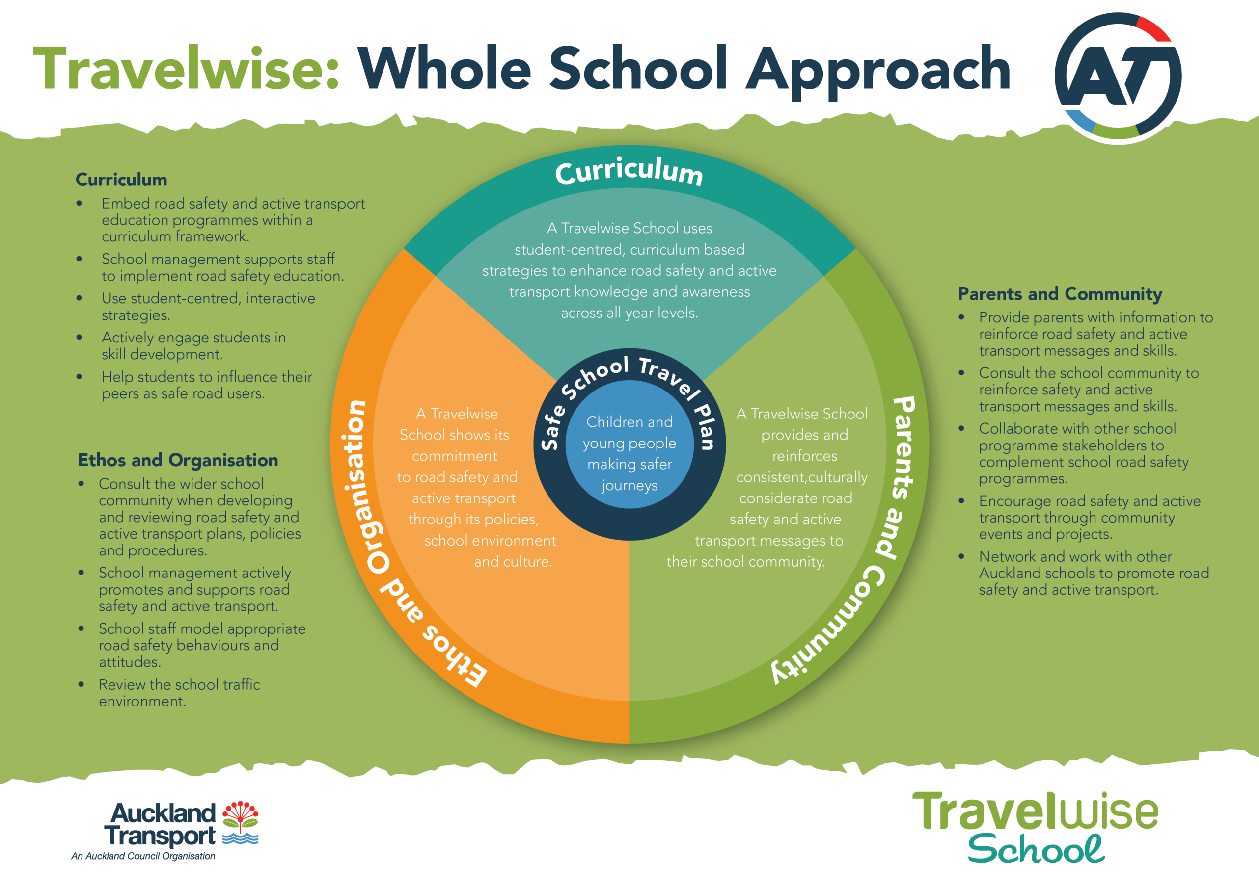
[School name here] TRAVELWISE VISION STATEMENT
Insert wording here

Reflecting on our progress
TERM 1 2016
TERM 2 2016
TERM 3 2016
TERM 4 2016
Drivers for 2017.
How are we going to achieve our Travelwise Vision?

Results am/pm average
Change the column titles to modes appropriate to your school eg: remove WSB from secondary schools etc
Type of survey | Year | Walk | WSB | Cycle | Bus | Family Car | Friends Car | Scooter | Car/Walk | Roll no.
 |  | % | % | % | % | % | % | % | % | -
Baseline
Roll call survey 1
Roll call survey 2

Safe School Travel Plan Overview

 |  | Term One |  | Term Two | Term Three | Term Four
 |  | Meeting:  Attendees: |  |  | Meeting:  Attendees:
Key Drivers for this year:
 |  | Term One  List relevant activities taking place each term (with dates and numbers participating if appropriate.) |  | Term Two | Term Three | Term Four
Curriculum  A Travelwise School uses student-centred, curriculum based strategies to enhance road safety and active transport knowledge and awareness across all year levels. |  | Example:
Checklist |  | Please tick appropriate box: |  |  |  | Yes | No |  | N/A
 |  | School management supports staff to implement road safety education and sees it as valuable
 |  | Road safety and active transport education programmes are embedded within a curriculum framework
 |  | Curriculum focus on road safety in classes in most/all levels throughout the school e.g. using statistics from annual survey, road safety week etc. Year groups impacted:
 |  | Students actively engaged in skill development for road safety or using active transport
 |  | Road Patrol training
 |  | Cycle / Scooter safety training (AT, School Community Officer, school)
 |  | Curriculum resources developed by AT and NZTA are used in classrooms
 |  | School Community Officers provide curriculum support on road safety themes – e.g. road patrol training, stepping out programme
 |  | Travelwise Student workshop attended
 |  | Students developing the ability to influence their peers as safe road users
 |  | Student group involved in planning and leading Travelwise action for the school
 |  | Comments Section/Describe any additional activities:
Self-assessment summary |  | Self-Assessment – How well have you integrated Travelwise into the curriculum (please circle and add in any supporting detail). |  |  |  | High  Med  Low
 |  | Term One  List relevant activities taking place each term (with dates and numbers participating if appropriate.) |  | Term Two | Term Three | Term Four
Ethos and Organisation

A Travelwise School shows its commitment to road safety and active transport through its policies, school environment and culture.
Checklist |  | Please tick appropriate box: |  |  |  | Yes |  | No | N/A
 |  | A Travelwise culture is evident in the school environment
 |  | School management actively promotes and supports road safety, active transport and Travelwise.
School has current road safety policy and or guidelines
School is proactive in and around their road environment
 |  | Road Safety Policy / guidelines developed or reviewed, e.g. pick up/drop off zones, cycling / scooting, bus safety, seat belts
 |  | The wider school community are consulted when developing and reviewing road safety plans, policies and procedures
 |  | Road Safety information communicated through the school newsletter and/or school website regularly
 |  | School uses opportunities for Professional development
 |  | School establishes minimum of one day per term to actively promote road safety and/or active transport, e.g. Road Safety Week, Back to School, Slow Down Around Schools, Wheels Day
 |  | Request for police or AT support for enforcement of road safety behaviour issues, e.g. red light running, unsafe parking
 |  | Enrolment information includes relevant road safety information and messages for new families
 |  | School staff model appropriate road safety behaviours and attitudes.
 |  | On board with Active transport e.g., space for bikes, scooters, staff to engage in active travel, have safe ‘pathways’ for students through car parks
 |  | Attend Travelwise Teacher workshop
 |  | School has participated in Travelwise regional events and promotions
 |  | School maintains a current overview for the year of all activities completed
 |  | Comments Section / Any additional activities:
 |  | Self-Assessment – How well has Travelwise been integrated into the culture and organisational framework of the school (please circle and add in any supporting detail). |  |  |  | High  Med  Low
 |  | Term One  List relevant activities taking place each term (with dates and numbers participating if appropriate.) |  | Term Two | Term Three | Term Four
Parents and Community
A Travelwise School provides and reinforces consistent, culturally considerate road safety and active transport messages to their school community.
Checklist |  | Please tick appropriate box: |  |  |  | Yes |  | No | N/A
 |  | School has implemented the TW programme in a way that reflects the unique school community
 |  | Provide parents with information to continue road safety and Travelwise messages at home
 |  | Travelwise messages and events are updated and relevant in school newsletter, on the school website, and at assemblies
 |  | Inform parents of classroom programmes that focus on road safety and Travelwise
 |  | A dedicated space for Travelwise information is displayed in a prominent place within the school for all students and families
 |  | Encourage road safety and active transport through community events and projects, e.g. School fairs
 |  | School staff and/or parents support road safety – e.g. staff patrolling the crossing facilities, parents working in drop off zones
 |  | Collaborate with other programme stakeholders
 |  | School work actively with the wider community towards increasing active transport and road safety, e.g. Walking School Buses, Park and Walk, Weekly Walking / Wheeling days, car-pooling
 |  | Education for school community about correct use of engineering facilities – e.g. using the crossing, drop off zone, bus stops
 |  | Networking independently with other schools, sharing ideas with others
 |  | Comments Section / Any additional activities:
 |  | Self-Assessment – How well has Travelwise been extended throughout the wider school community? (Please circle and add in any supporting detail). |  |  |  | High  Med  Low
 |  | Term One |  | Term Two | Term Three | Term Four
Monitoring / Reporting
- Is your survey completed and submitted to AT?
- Do you have any other data or evaluation information?
Funding
- Project budget
- Professional Development
- Resources received
Environment
- Infrastructure development
- Infrastructure delivery
- Police and Parking Officers Enforcement

Self-Recommendation for Travelwise Award: | Bronze / Silver / Gold / N/A
Reasons why we deserve this award level:
(Please provide a brief explanation of why you have assessed yourself at either Bronze, Silver or Gold. Make sure the detail in this overview supports your assessment and attach any supporting information you want to include – pictures, examples of promotional material etc.)

Supporting Information for the Awards 2016

The Travelwise Awards process is different to previous years. AT would like to invite schools to apply for an award, based on self -assessment along with completion of the Travelwise Annual Survey and submission of this document, your Safe School Travel Plan.

- Submitting an application for an award is voluntary but only schools who do so will be given awards.

- To assist your self-assessment, an example of a GOLD school is listed below. See how you compare.
- Wherever you are at, the information in your overview should support and demonstrate your self-assessment. Please note this assessment is of the school as a whole, not of your performance as a Travelwise lead teacher.
- Generally a Gold school would be able to provide evidence of High commitment, curriculum and ethos; a Silver school would be largely medium and a Bronze would be at a lower level.

Please note: This assessment reflects your school’s commitment to a Whole School Approach to Travelwise and the principles involved. At times, along with your progress with the whole programme you may focus on a larger project or activity such as building a cycle track or starting up a number of Walking School Buses. You may choose to submit some information about an exceptional larger project rather than basing your award assessment solely on the Whole School Approach. Just make sure you include some great detail about the project and demonstrate how that project fits with your wider Travelwise programme.

Features of a GOLD School |  | Examples
Commitment | The school actively engages with AT to resource TW at their school | - Have a functional relationship with AT  - Participates actively in most Travelwise AT organised events  - Has an up to date Travelwise vision in SSTP  - Evaluates their Travelwise Activities  - School management fully supports and endorses Travelwise
 | A Travelwise culture is evident in the school environment | - The school proactively implements elements of TW across school  - Ongoing communication with community  - Shares with CTC and other schools their learning/activities
 | School has implemented the TW programme in a way that reflects the unique school community | - Sense of ownership  - Proactive in Travelwise  - Self sufficient  - Create own ideas and activities
Curriculum | School uses opportunity for Professional development | - Attends AT workshops for staff and students  - Conducts staff meetings/training with support from AT or other outside organisations
 | Embed road safety and active transport education programmes within a curriculum framework | - Curriculum focus in classes in most/all levels throughout the school  - Management led support in curriculum implementation  - Creating curriculum resources/plans  - Use curriculum resources developed by AT and NZTA
 | Students engaged and leading Travelwise within the school | - Actively engaging students in skill development around sustainability and road safety  - Student centred activities  - Established Student group – influencing peers and/or parents  - Students trained for Road Patrol
Ethos and Organisation | School has current road safety policy and or guidelines | - Apply and review road safety policy regularly
 | School is proactive in and around their road environment | - School staff model road safety behaviour  - monitor crossings, gates, safety at the school gate  - School report issues independently to AT
 | The school actively promotes and endorses Travelwise | - Regular communication to parents and community regularly e.g., website, New Entrant Flyer, newsletters  - On board with Active transport e.g., space for bikes, scooters, staff to engage in active travel, have safe ‘pathways’ for students through car parks etc.
Community | Provide parents with information to reinforce road safety and active transport messages and skills | - Consult with the community about what is relevant to be taught around road safety  - Community involvement links to the vision  - Provide parents with information to teach road safety at home
 | Collaborate with other programme stakeholders | - Community participates in Travelwise activities e.g. walk to school promotions, special events and park and walk activities  - police sports trust, health promoting schools Enviroschools, local board  - Networking independently with other schools, sharing ideas with others
Modal Shift | To reduce am car trips to school by 4% from baseline survey results | - Complete annual survey each year to measure modal shift results

Proposed projects | Rationale | Forecast | Who | Update

