EOI Response Template
Pier 1, Downtown Ferry Terminal: Activation Opportunity
Procurement Number: 440-20-665-GS
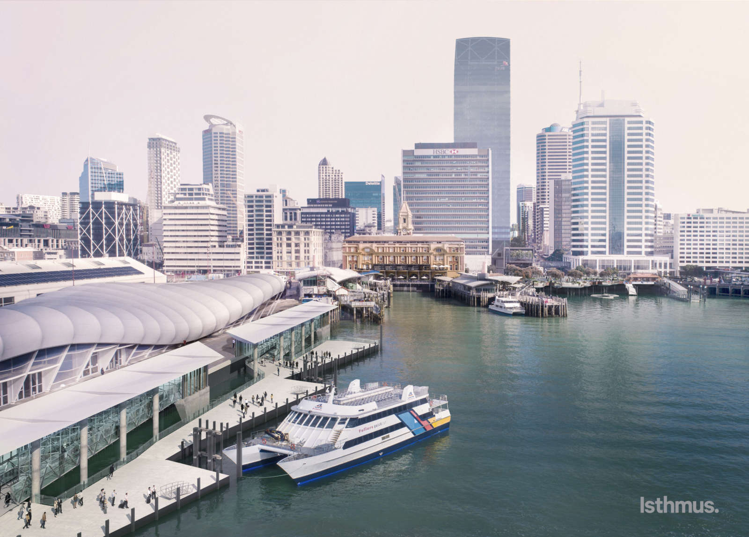

Table of Contents
1 Submission Checklist for participants 3
1.1 Information to be submitted by participants 3
2 EOI Attribute Response 4
2.1 Preconditions 4
2.2 Proposed use, product or service offering (25%) 4
2.3 Service delivery model (20%) 4
2.4 Rental offer and covenant strength (25%) 4
2.5 Track record (15%) 5
2.6 Business and marketing plan (including fitout) (15%) 5

Submission Checklist for participants

Information to be submitted by participants
This is an optional EOI response form to help guide the structure of your response. By using this template, respondents will ensure they have provided all requirements in line with the EOI evaluation criteria. You can complete the EOI response form in the fields within this template or send a custom response form.
If any information you provide is commercially sensitive to your business, you must let us know. Please mark the information ‘Commercially Sensitive’ or ‘Confidential Information’. It is not acceptable to render this whole document confidential unless this is truly the case.
The following information is to be submitted by each participant.
EOI Information
Documents | Included
Completed ROI Response Template (this document) | ☐
Precondition requirement as per Section 2.1 Precondition | ☐
Additional supporting documents | ☐

EOI Attribute Response
In this section you are asked to demonstrate your business’s ability against Evaluation Attributes set out in the EOI. If there is anything that you do not understand ask our Point of Contact to clarify before the Deadline for Questions.

Preconditions
You must be able to answer ‘yes’ to each of these precondition requirements. Make sure you are able to verify that this is the case, if asked.
Preconditions | Meets
You agree that: | Yes/No
The terms of the licence are acceptable.
The requirements for fitout design and plans must meet all necessary consenting and building requirements.

All associated costs and consents to meet the above requirement are the responsibility of the lessee.

All consents required for your proposed service offering will be obtained in time so that there is no impact on delivery timeframes.

Proposed use, product or service offering (25%)

Service delivery model (20%)

Rental offer and covenant strength (25%)

Track record (15%)

Business and marketing plan (including fitout) (15%)

