Have your say on changes to West Auckland bus services
Consultation is open from 4 April to 5 June 2022.

Table of Contents
Big changes for West Auckland 3
Project overview 5
Why are we proposing these changes? 9
What are the trade-offs? 11
New bus facilities at Te Atatū, Lincoln Road and the NorthWest Centre at Westgate 12
Westgate bus interchange 13
Lincoln Road bus interchanges 14
Te Atatū bus interchanges 14
What is being proposed? 15
Western Express - WX1 15
11T and 11W 16
New local services: 17
Routes changing: 19
What’s proposed for your area? 21
Helensville, Waimauku, Huapai and Kumeū 21
Henderson 22
Lincoln Road 23
Massey 23
Riverhead 23
Rosebank Road 24
Royal Heights 24
Swanson, Rānui and Universal Drive 24
Te Atatū Peninsula 26
Te Atatū South 27
Waitākere Hospital 27
Waitākere Village 28
West Harbour, Hobsonville, and Scott Point 28
West Hills 29
Western Heights 29
Westgate 30
Whenuapai 31
Williamson Ave and Grey Lynn 31
How often will buses run? 32
WX1 33
11T 33
11W 34
Come and have a chat 43
For more information 47

Big changes for West Auckland
Auckland Transport is proposing to transform the bus network in West Auckland so you can use buses to travel to more places more often. The changes we’re proposing aim to create more reliable and frequent bus services.

The changes include:
- A new Western Express WX1 bus service to provide more frequent services on the Northwestern Motorway.
- Local routes connecting with motorway services at new bus interchanges at Te Atatū, Lincoln Road and Westgate.
- Increasing the all-day frequency of route 131 and renumbering it route 13 for easier local trips and connecting to the new bus interchanges at Te Atatū and trains at Henderson.
- Increasing the all-day frequency of route 120 between Henderson and the North Shore and renumbering it route 12.
- Most buses running more frequently and later in the evenings.
- Creating a simpler bus network so it is easier to understand.
- Most customers will need to transfer to motorway services to travel to the City Centre.

Tell us what you think about the proposed changes by Sunday 5 June 2022.

Project overview
In 2017, Auckland Transport launched a new network of bus services for West Auckland. This connected more people to more places, took advantage of new electric trains and our new fares system that enabled customers to transfer between buses and trains during their journey without paying multiple fares. At that time we didn’t have the infrastructure in place to allow a fully interconnecting network of frequent bus routes.

We’re now working with Waka Kotahi NZ Transport Agency to extend and improve bus shoulder lanes along the Northwestern Motorway and adding bus priority to the on and off ramps to create the first step towards a rapid transit corridor along State Highway 16. When this is complete in mid-2023 it will allow buses to connect at new bus interchanges at Te Atatū, Lincoln Road and Westgate and enable an all-day, frequent public transport option along the Northwestern Motorway.

The changes we are proposing here would allow more people to simply ‘turn up and go’ rather than planning trips around a timetable. They will also enable access to more local destinations making public transport more useful for a greater range of travel purposes. This will provide a realistic alternative to adding more cars to our roads.

To enable frequent all-day bus services, these changes will require some passengers to transfer between buses at key interchanges to get where they want to go. Auckland Transport and Waka Kotahi are working to provide good facilities to make transferring as easy as possible.

The proposed changes will impact some existing customers’ journeys. The overall objective of these changes is to make public transport simpler and more useful for as many people as possible including those who don’t currently use it.

Transcriber’s note: The schematic map below show the proposed all-day network. The proposed all-day network shows three new motorway bus services WX1, 11T and 11W connecting at NorthWest, Lincoln and Te Atatū interchanges along the Northwestern Motorway. The map also shows local bus services connecting at Rānui, Henderson, New Lynn and Avondale train stations.

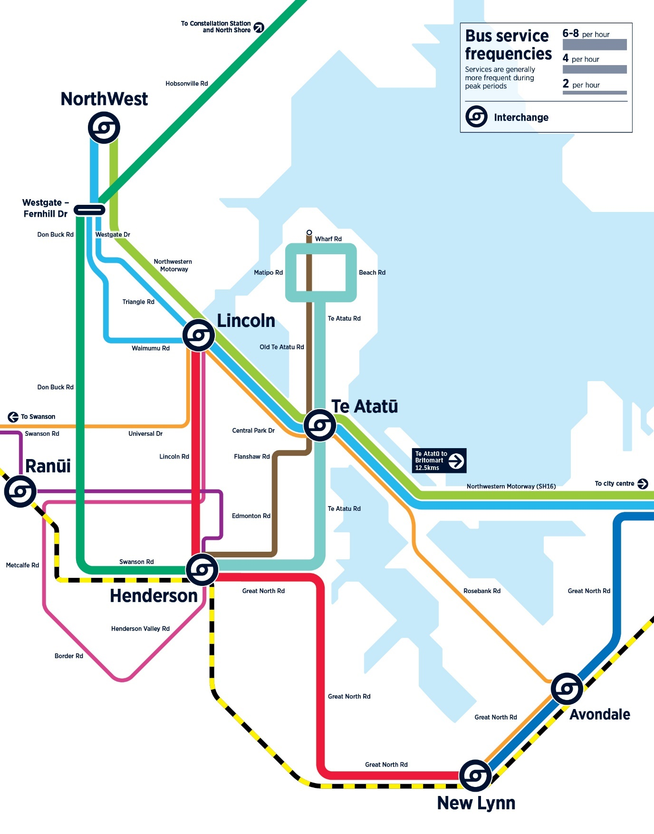

Why are we proposing these changes?
The northwest is growing with more houses, more jobs and more people needing to travel. State Highway 16 is a major route for bus services from the northwest, and is important to improve public transport choices for the area. The northwest has limited transport options for travelling to work, study and social activities. Over 60 per cent of people living in the northwest commute out of the area and more travel to work by car than in any other region in Auckland.

The current lack of bus interchanges and bus priority lanes means your bus network is not as frequent, efficient and reliable as it could be. These changes are designed to offer a better public transport network by removing duplication and using buses more efficiently. By sharing resources along the common motorway section of their routes, we can run more bus trips on the Northwestern Motorway all day, unhindered by traffic conditions on local roads. This also allows more local bus trips to run unaffected by traffic conditions on the motorway. By having buses working together as a connected network rather than as individual routes it makes it possible to reach more places at more times of the day with the comfort of knowing, in many cases you can simply ‘turn up and go’.

With these changes almost three times as many people will be within walking distance to a frequent bus route.

In order to make this connecting network of buses, and remove duplication, the current direct trips into the City Centre from Don Buck Road, Henderson, Te Atatū and Helensville will require passengers to transfer between buses so everyone can share the same bus rather than requiring multiple vehicles.

Improving public transport means more people can use it easily, which helps to free up the roads for those who really need it. Effective public transport can reduce congestion and carbon emissions, reduce the need to take up land to provide car parking spaces, connect communities, improve health outcomes, and provide independent mobility for those who can’t or choose not to drive.

What are the trade-offs?
To improve public transport for West Auckland overall we have needed to make some trade-offs:

• The removal of direct bus services to the City Centre from some areas – these buses can be better used to create more motorway and local bus services.

• The need to transfer between services – while transfers may not be desirable to some, they are essential to create frequency. They enable buses to be utilised more effectively to run more often and provide access to more destinations. The HOP card fare system makes connecting between services easier. Fares are based on the number of zones you travel through. This means you can transfer between AT buses, trains and ferries and pay just one fare for your entire journey with your AT HOP card.

New bus facilities at Te Atatū, Lincoln Road and the NorthWest Centre at Westgate
Auckland Transport and Waka Kotahi NZ Transport Agency are currently creating the following public transport facilities and bus priority measures in Northwest Auckland.

Transcriber’s note: The map below shows the Northwestern Bus Improvement project. The map shows Te Atatū, Lincoln Road and Westgate interchanges along the Northwestern Motorway. The map also shows existing bus shoulder lanes (pink) and proposed bus shoulder lanes (green) along State Highway 16.

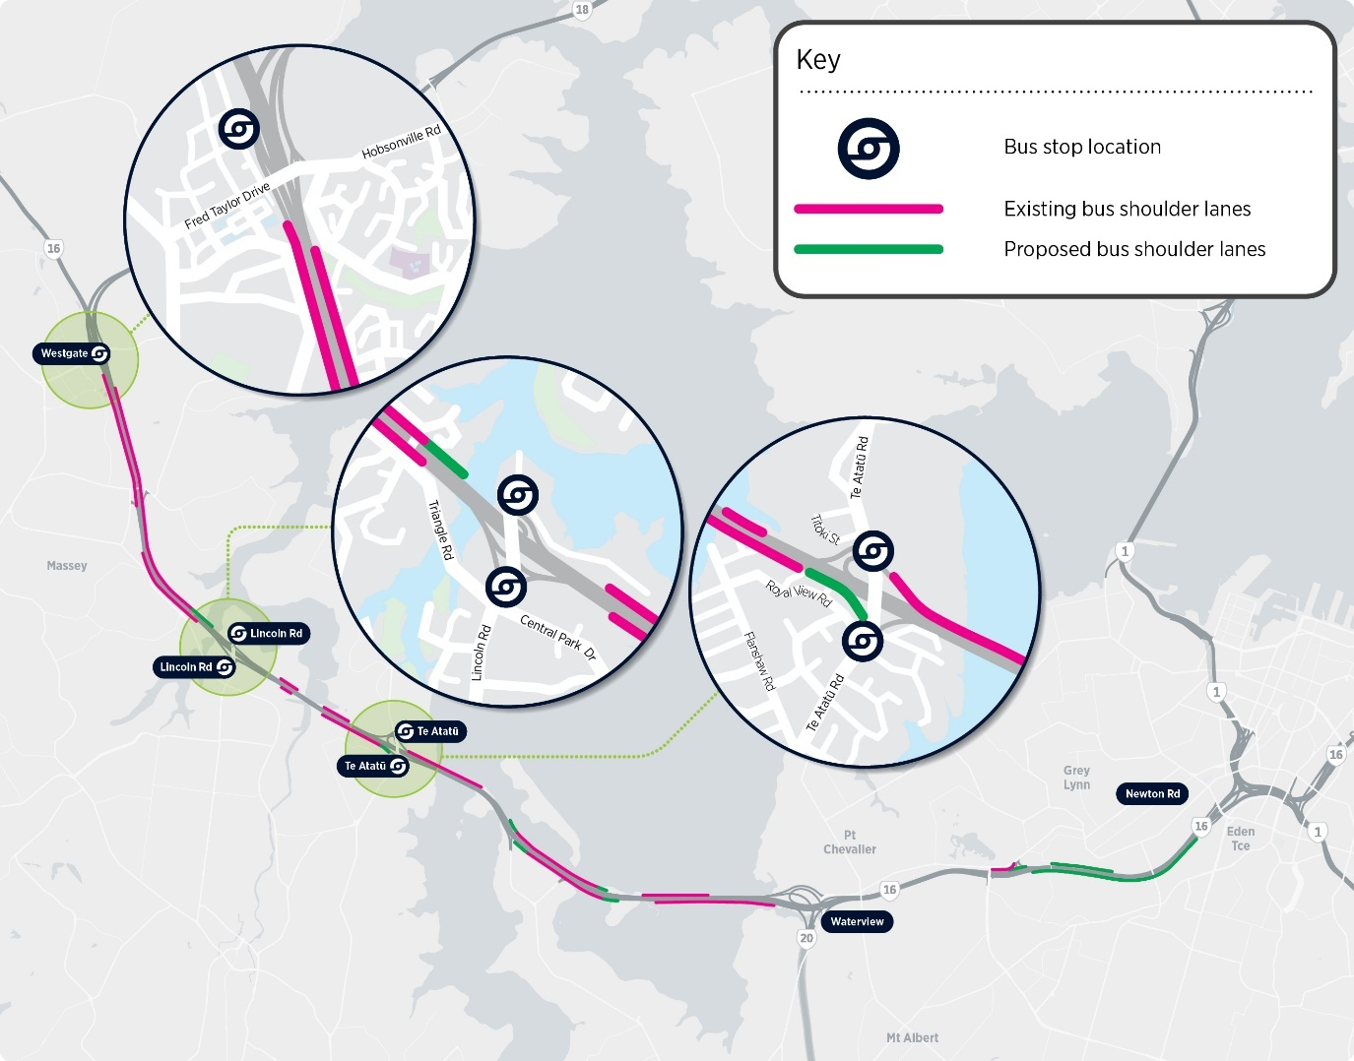

Westgate bus interchange
We’re building new bus stops at the NorthWest Shopping Centre to enable changes between buses there. The interchange will be significantly improved in the near future. The Fernhill Drive bus stops will remain with some changes to the routes using them.

Bus routes using the NorthWest bus stops are WX1, 11T, 11W, 111, 112, 114, 116, 122, 123, 125 and 126.

Bus routes using the Fernhill Drive bus stops are 11T, 11W, 12, 111, 116, 122, 123, 125 and 126.

Lincoln Road bus interchanges
Bus stops are being built on Lincoln Road and the nearby motorway on and off ramps.

Te Atatū bus interchanges
Bus stops are being built on Te Atatu Road and the nearby motorway on and off ramps.

To provide a more reliable and quicker bus journey into the City Centre, the bus shoulder lanes on the Northwestern Motorway are being extended between Westgate and Newton Road. This will mean almost 20km of bus shoulder lanes on the motorway. Improvements are also being made at motorway interchanges and on Te Atatu Road and Lincoln Road to increase priority for buses. This will make bus trips quicker and more reliable.

To find out more about the infrastructure changes, visit the Northwestern Bus Improvement page on the Auckland Transport website.

What is being proposed?
Auckland Transport are proposing changes to many of the current bus routes in West Auckland including introducing new Northwestern Motorway bus services. The new Northwestern Motorway bus services are the WX1, 11T and 11W.

Western Express - WX1
- Travel from Westgate to City Centre via motorway.
- This will be the quickest way to travel between Westgate and the City Centre using public transport.
- Uses bus interchanges at Westgate, Lincoln Road, Te Atatū and bus stops on Karangahape Road, Queen Street/Albert Street and Lower Albert Street.
- First trip from 5:30am. It will run every 10 minutes from 7am to 7pm, every 15 minutes from 7pm to 11:30pm, seven days a week.
- Gets on and off motorway at Newton Road in the City Centre.

11T and 11W
- Maintains the connections on Great North Road in Point Chevalier and Grey Lynn. Provides connections to Point Chevalier, Western Springs, Grey Lynn, Carrington Unitec and Auckland Zoo.
- Travels on motorway between Lincoln Road and Point Chevalier.
- 11T travels through Massey on Triangle Road and 11W travels on Waimumu Road.
- Uses new bus interchanges at Westgate, Lincoln Road and Te Atatū.
- 11T and 11W each run every 30 minutes and combine to run every 15 minutes between Lincoln Road and the City Centre at all times from 5:30am to 11:30pm, seven days a week.

The WX1, 11T and 11W will be the only bus services travelling along the Northwestern Motorway. Customers will need to transfer between local bus services and motorway services for trips currently using routes 125X, 129, 132, 132X, 133, 133X and 134.

New local services:
- Route 12 is the renumbered 120. It follows the same route as the 120 but runs more often. Some school day trips will continue to Smales Farm and Akoranga as they do currently.
- Route 13 replaces 131. It follows the same route as the 131 but runs more often. Use this frequent bus to make connections at Henderson for trains and Te Atatū interchanges for buses to City Centre, Rosebank Road, Lincoln Road and Westgate.
- Route 14 replaces 14T and 14W. It will travel between New Lynn, Henderson and the new bus interchanges at Lincoln Road only. The sections between Lincoln Road and Westgate will be replaced by routes 11T and 11W.
- Route 116 is a proposed new route for West Hills when the roads are ready.
- Route 123 is a new bus route between southern Huapai and Westgate. It will alternate with the 122 to provide more frequent bus services to Huapai and Kumeū.
- Route 135 replaces the Edmonton Road section of the 134 and adds more bus services to Te Atatū Peninsula.
- Route 145 replaces 141 and 142 through Western Heights connecting to Henderson and the new Lincoln Road bus interchanges.
- Route 147 is a new service between Swanson and Henderson and provides a bus connection to Rānui Station.
- Route 149 travels from Rānui to New Lynn through Rosebank. It replaces the 138 in Rosebank and connects with other buses at the new interchanges at Lincoln Road and Te Atatū.
- Route 148 is the evening and weekend version of the 149 connecting Rānui with the Lincoln Road interchange but doesn’t continue on to Rosebank and New Lynn.

Routes changing:
- Route 14T and 14W shortened to run between New Lynn and Lincoln Road only. Renumbered 14. Sections between Lincoln Road and Westgate replaced by 11T and 11W.
- 110 renumbered 11T.
- Route 111 extended to NorthWest Shopping Centre.
- Route 112 and 114 changes at Westgate to travel to new bus stops at NorthWest Shopping Centre. Will no longer go to Fernhill Drive bus stops.
- Route 120 upgraded to a frequent route. It is renumbered route 12.
- New bus stops for bus services 122 and 125 added at NorthWest Shopping Centre.
- Bus service 125X replaced with additional 125 bus services and the WX1 bus service.
- Route 126 change to travel through Riverhead Village. New bus stops added at NorthWest Shopping Centre.
- Route 129, 131, 132, 132X, 133, 133X and 134 replaced with new local services and motorway services.
- Routes 141 and 142 replaced mostly with new route 145.
- Route 146 shortened. Runs between Waitākere Village and Swanson only. Route change through Waitākere Village. New route 147 continues to connect Swanson and Henderson.
- Route 195 travels on Williamson Ave not Great North Road between Grey Lynn Shops and Karangahape Road.

There will be no changes to other bus services or school bus services as part of this project.

What’s proposed for your area?
The list of changes below are proposed for your area. To view the map of the proposed bus routes, click this link here.

Helensville, Waimauku, Huapai and Kumeū
• Customers travelling to the City Centre will need to transfer at the NorthWest Shopping Centre to a WX1, 11T or 11W service.
• Direct bus service 125X will be removed and replaced with the 125 bus service.
• Bus service 125 will run every 30 minutes at peak times, hourly throughout the day and will run later into the evening.
• New bus service 123 for Huapai serving southern Huapai.
• Bus services 122 will run more often so that for the combined bus services 122, 123 and 125 there will be a bus every 15 minutes at peak times from Huapai to Westgate and every 30 minutes during the day.
• Bus services 122, 123 and 125 will use new bus stops at the NorthWest Shopping Centre as well as the Fernhill Drive bus stops.
• More buses to City Centre from Westgate, with quicker journey times.

Henderson
• Customers travelling to City Centre will need to transfer at the new Te Atatū interchanges. Transfer there to WX1, 11T and 11W bus services to City Centre. Direct bus services will be removed.
• Bus service 131 becomes route 13 running every 15 minutes until midnight to connect customers to the new Te Atatū interchanges.
• Bus service 134 is replaced with route 135 on Edmonton Rd between Henderson and Te Atatū Peninsula.
• Bus service 120 will be renumbered 12. It will run every 15 minutes throughout the day and every 30 minutes after 7pm, seven days a week.

Lincoln Road
• Frequent route 14 will continue to travel between Lincoln Road and New Lynn through Henderson but the sections between Lincoln Road and Westgate will be replaced by 11T and 11W.

Massey
• Bus service 129 will no longer operate.
• Bus service 120 will be renumbered route 12. It will run every 15 minutes throughout the day and every 30 minutes after 7pm, seven days a week.
• 11T and 11W will travel into the City Centre.

Riverhead
• 126 changes its route through Riverhead Village to run on Riverhead Point Drive, Pohutukawa Parade and Great North Road so it uses bus stops that are closer to houses.

Rosebank Road
• New bus service 149 will replace bus service 138 and will provide connections to Te Atatū and Lincoln Road interchanges and Rānui. Operates Monday to Friday until about 7pm and will run more often than bus service 138.
• Removal of direct bus service 138 to Henderson.
• No change to route 22R or bus service 191.

Royal Heights
• Bus service 111 will run every 30 minutes at all times and the NorthWest Shopping Centre.
• Transfer from the 111 bus service to 11T for connections to and from the City Centre.

Swanson, Rānui and Universal Drive
• Bus service 120 will be renumbered route 12. It will run every 15 minutes throughout the day and every 30 minutes after 7pm, seven days a week. It will use bus stops on Fernhill Drive but will not go to the NorthWest Shopping Centre and so will not connect with the WX1 bus service.
• No change to bus service 143.
• New bus service 145 will replace most of the routes 141 and 142 through Rānui. It will connect to the new Lincoln Road interchanges.
• Bus service 146 will run between Waitākere Village and Swanson only.
• Bus service 147 maintains connection between Swanson, Henderson and The Trusts Arena, and provides a new connection with Rānui Station.
• Bus service 149 provides a connection from Rānui to the interchanges at Lincoln Road (and the connections to other bus services there) and Rosebank. At evenings and weekends the 148 bus service will replace the 149 bus service and will only operate between Rānui and Lincoln Road.
• There will be no public bus on Rathgar Road outside Waitākere College, Liston College and St Dominic’s Catholic College but buses will run more often on Swanson Rd (route 12).

Te Atatū Peninsula
• Customers travelling to City Centre will need to transfer at the new Te Atatū interchanges. Transfer there to WX1,11T or 11W services to City Centre. Direct bus services 132 and 132X will be removed.
• From the interchanges buses travel to City Centre, Henderson, Westgate, Lincoln Road interchanges and Rosebank Road.
• More all-day, evening and weekend bus services.
• Route 13 replaces bus service 131, running every 8 to 15 minutes to connect with buses at the new Te Atatū interchanges and trains at Henderson.
• New bus service 135 along northern section of Te Atatu Road up to Rewarewa Road.
• Customers can choose to connect to Westgate and the NorthWest Shopping Centre via WX1, 11T or 11W rather than having to go via Henderson.

Te Atatū South
• Customers travelling to City Centre will need to transfer at the new Te Atatū interchanges. Transfer there to WX1, 11T or 11W services to City Centre. Bus services 133, 133X and 134 will be removed.
• Route 13 replaces bus service 131, running every 8 to 15 minutes to connect with buses at the new Te Atatū interchanges and trains at Henderson.
• Bus service 135 replaces bus service 134 on Edmonton Road. Runs between Henderson and Te Atatū Peninsula.
• For Rosebank Road use route 149 from the new Te Atatū interchanges.
• Can connect to Westgate and the NorthWest Shopping Centre via WX1, 11T or 11W rather than having to go via Henderson.
• More buses more often throughout the day and evening.

Waitākere Hospital
• Customers travelling from Massey and Westgate on 14T or 14W will need to transfer at the new bus interchanges at Lincoln Road. Use 11T or 11W and transfer to route 14 at the interchanges.

Waitākere Village
• Bus service 146 will run between Waitākere Village and Swanson only.
• Route will change through Waitākere Village to travel on Northfield Road and McEntee Road to stop closer to more houses.
• It will run every 30 minutes at peak times and hourly at other times.
• New bus service 147 will continue to connect Swanson with Henderson.

West Harbour, Hobsonville, and Scott Point
• Bus services 112 and 114 will go to the NorthWest Shopping Centre and no longer go to Fernhill Drive bus stops at Westgate.
• Auckland Transport is waiting for the completion of Joshua Calder Drive which will be wide enough for buses to operate in Scott Point. When this happens bus service 112 will then travel between the NorthWest Shopping Centre and Hobsonville Point through Scott Point. Bus service 112 has a good connection to the WX1 bus service to the City Centre.
• Bus service 120 will be renumbered route 12. It will run every 15 minutes throughout the day and every 30 minutes after 7pm, seven days a week.

West Hills
• A new one-way loop bus service 116 will connect the area to Westgate and the NorthWest Shopping Centre. Will only start running once the necessary roads are completed.

Western Heights
• New bus service 145 will replace routes 141 and 142 to provide a connection through to the new bus interchanges at Lincoln Road. This may mean a longer trip to Henderson for some people.
• No change to bus service 143.

Westgate
• New bus stops will be built at the NorthWest Shopping Centre.
• New WX1 bus service will travel on the motorway between Westgate and the City Centre connecting with bus stops at Lincoln Road and Te Atatū. First trip from 5:30am. It runs every 8 to 10 minutes on weekdays during the day, every 15 minutes from 7pm to 11:30pm, and weekends.
• For Great North Road between Point Chevalier and the City Centre use routes 11T (via Triangle Road) and 11W (via Waimumu Road). They will run every 30 minutes throughout the day. Combined they will run every 15 minutes between Lincoln Road and the City Centre.
• Routes 14T and 14W will no longer travel between Lincoln Road and Westgate. For Waitākere Hospital, Henderson and New Lynn use 11T, 11W or WX1 bus services and change at Lincoln Road to route 14.
• Bus service 120 will be renumbered route 12. It will run every 15 minutes throughout the day and every 30 minutes after 7pm, seven days a week.
• It will use bus stops on Fernhill Drive but will not go to the NorthWest Shopping Centre and so will not connect with the WX1 bus service.

Whenuapai
• Bus service 114 will go to the NorthWest Shopping Centre and no longer go to Fernhill Drive bus stops at Westgate.
• More buses to City Centre from Westgate, with quicker journey times.

Williamson Ave and Grey Lynn
• Bus service 195 will travel along Williamson Ave in Grey Lynn in place of bus service 134.

How often will buses run?
Transcriber’s note: The table below shows the approximate proposed running hours and frequency for the bus routes.
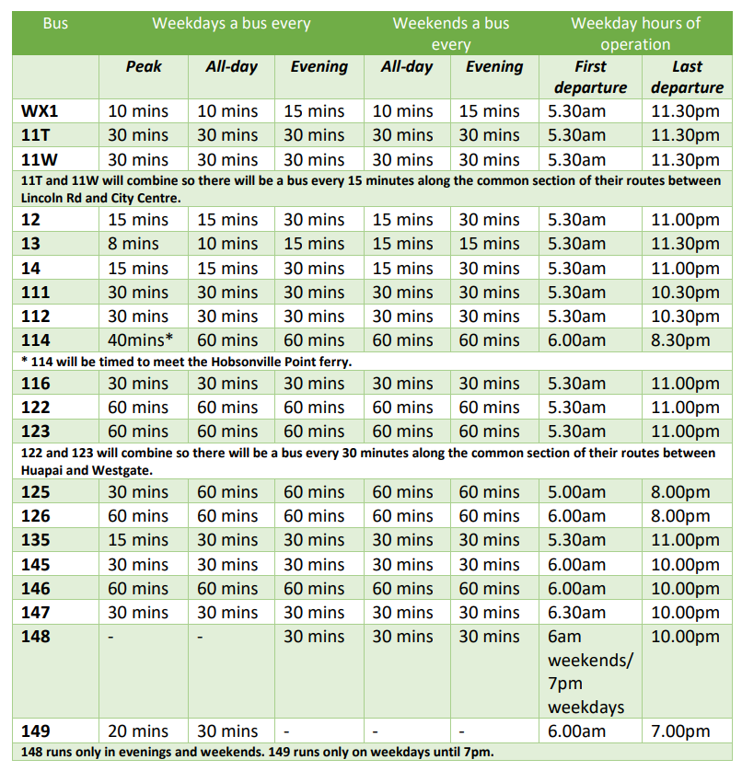
WX1 is proposed to run on:
- Weekdays a bus every 10 minutes in peak.
- Weekdays a bus every 10 minutes all-day.
- Weekdays a bus every 15 minutes in the evening.
- Weekday hours of operation first departure at 5:30am and last departure at 11:30pm.
- Weekends a bus every 10 minutes all-day.
- Weekends a bus every 15 minutes in the evening.

11T is proposed to run on:
- Weekdays a bus every 30 minutes in peak.
- Weekdays a bus every 30 minutes all-day.
- Weekdays a bus every 30 minutes in the evening.
- Weekday hours of operation first departure at 5:30am and last departure at 11:30pm.
- Weekends a bus every 30 minutes all-day.
- Weekends a bus every 30 minutes in the evening.

11W is proposed to run on:
- Weekdays a bus every 30 minutes in peak.
- Weekdays a bus every 30 minutes all-day.
- Weekdays a bus every 30 minutes in the evening.
- Weekday hours of operation first departure at 5:30am and last departure at 11:30pm.
- Weekends a bus every 30 minutes all-day.
- Weekends a bus every 30 minutes in the evening.

Bus services 11T and 11W will combine so there will be a bus every 15 minutes along the common section of their routes between Lincoln Road and City Centre.

Route 12 is proposed to run on:
- Weekdays a bus every 15 minutes in peak.
- Weekdays a bus every 15 minutes all-day.
- Weekdays a bus every 30 minutes in the evening.
- Weekday hours of operation first departure at 5:30am and last departure at 11:00pm.
- Weekends a bus every 15 minutes all-day.
- Weekends a bus every 30 minutes in the evening.

Route 13 is proposed to run on:
- Weekdays a bus every 8 minutes in peak.
- Weekdays a bus every 10 minutes all-day.
- Weekdays a bus every 15 minutes in the evening.
- Weekday hours of operation first departure at 5:30am and last departure at 11:30pm.
- Weekends a bus every 15 minutes all-day.
- Weekends a bus every 15 minutes in the evening.

Route 14 is proposed to run on:
- Weekdays a bus every 15 minutes in peak.
- Weekdays a bus every 15 minutes all-day.
- Weekdays a bus every 30 minutes in the evening.
- Weekday hours of operation first departure at 5:30am and last departure at 11:00pm.
- Weekends a bus every 15 minutes all-day.
- Weekends a bus every 30 minutes in the evening.

Bus service 111 is proposed to run on:
- Weekdays a bus every 30 minutes in peak.
- Weekdays a bus every 30 minutes all-day.
- Weekdays a bus every 30 minutes in the evening.
- Weekday hours of operation first departure at 5:30am and last departure at 10:30pm.
- Weekends a bus every 30 minutes all-day.
- Weekends a bus every 30 minutes in the evening.

Bus service 112 is proposed to run on:
- Weekdays a bus every 30 minutes in peak.
- Weekdays a bus every 30 minutes all-day.
- Weekdays a bus every 30 minutes in the evening.
- Weekday hours of operation first departure at 5:30am and last departure at 10:30pm.
- Weekends a bus every 30 minutes all-day.
- Weekends a bus every 30 minutes in the evening.

Bus service 114 is proposed to run on:
- Weekdays a bus every 40* minutes in peak.
- Weekdays a bus every 60 minutes all-day.
- Weekdays a bus every 60 minutes in the evening.
- Weekday hours of operation first departure at 6:00am and last departure at 8:30pm.
- Weekends a bus every 60 minutes all-day.
- Weekends a bus every 60 minutes in the evening.

*Bus service 114 will be timed to meet the Hobsonville Point ferry.

Bus service 116 is proposed to run on:
- Weekdays a bus every 30 minutes in peak.
- Weekdays a bus every 30 minutes all-day.
- Weekdays a bus every 30 minutes in the evening.
- Weekday hours of operation first departure at 5:30am and last departure at 10:30pm.
- Weekends a bus every 30 minutes all-day.
- Weekends a bus every 30 minutes in the evening.

Bus service 122 is proposed to run on:
- Weekdays a bus every 60 minutes in peak.
- Weekdays a bus every 60 minutes all-day.
- Weekdays a bus every 60 minutes in the evening.
- Weekday hours of operation first departure at 6:00am and last departure at 9:00pm.
- Weekends a bus every 60 minutes all-day.
- Weekends a bus every 60 minutes in the evening.

Bus service 123 is proposed to run on:
- Weekdays a bus every 60 minutes in peak.
- Weekdays a bus every 60 minutes all-day.
- Weekdays a bus every 60 minutes in the evening.
- Weekday hours of operation first departure at 6:30am and last departure at 8:30pm.
- Weekends a bus every 60 minutes all-day.
- Weekends a bus every 60 minutes in the evening.

Bus services 122 and 123 will combine so there will be a bus every 30 minutes along the common section of their routes between Huapai and Westgate.

Bus service 125 is proposed to run on:
- Weekdays a bus every 30 minutes in peak.
- Weekdays a bus every 60 minutes all-day.
- Weekdays a bus every 60 minutes in the evening.
- Weekday hours of operation first departure at 5:00am and last departure at 8:00pm.
- Weekends a bus every 60 minutes all-day.
- Weekends a bus every 60 minutes in the evening.

Bus service 126 is proposed to run on:
- Weekdays a bus every 60 minutes in peak.
- Weekdays a bus every 60 minutes all-day.
- Weekdays a bus every 60 minutes in the evening.
- Weekday hours of operation first departure at 5:00am and last departure at 8:00pm.
- Weekends a bus every 60 minutes all-day.
- Weekends a bus every 60 minutes in the evening.

Bus service 135 is proposed to run on:
- Weekdays a bus every 15 minutes in peak.
- Weekdays a bus every 30 minutes all-day.
- Weekdays a bus every 30 minutes in the evening.
- Weekday hours of operation first departure at 5:30am and last departure at 11:00pm.
- Weekends a bus every 30 minutes all-day.
- Weekends a bus every 30 minutes in the evening.

Bus service 145 is proposed to run on:
- Weekdays a bus every 30 minutes in peak.
- Weekdays a bus every 30 minutes all-day.
- Weekdays a bus every 30 minutes in the evening.
- Weekday hours of operation first departure at 6:00am and last departure at 10:00pm.
- Weekends a bus every 30 minutes all-day.
- Weekends a bus every 30 minutes in the evening.

Bus service 146 is proposed to run on:
- Weekdays a bus every 60 minutes in peak.
- Weekdays a bus every 60 minutes all-day.
- Weekdays a bus every 60 minutes in the evening.
- Weekday hours of operation first departure at 6:00am and last departure at 10:00pm.
- Weekends a bus every 60 minutes all-day.
- Weekends a bus every 60 minutes in the evening.

Bus service 147 is proposed to run on:
- Weekdays a bus every 30 minutes in peak.
- Weekdays a bus every 30 minutes all-day.
- Weekdays a bus every 30 minutes in the evening.
- Weekday hours of operation first departure at 6:30am and last departure at 10:00pm.
- Weekends a bus every 30 minutes all-day.
- Weekends a bus every 30 minutes in the evening.

Bus service 148 is proposed to run on:
- Weekdays a bus every 30 minutes in the evening.
- Weekday hours of operation first departure at 6:00am on weekends and 7:00pm on weekdays. Last departure at 10:00pm.
- Weekends a bus every 30 minutes all-day.
- Weekends a bus every 30 minutes in the evening.

Bus service 149 is proposed to run on:
- Weekdays a bus every 20 minutes in peak.
- Weekdays a bus every 30 minutes all-day.
- Weekday hours of operation first departure at 6:00am and last departure at 7:00pm.

Bus service 148 runs only in evenings and weekends. Bus service 149 runs only on weekdays until 7pm.

Come and have a chat
If you have questions about these proposed changes, or would like to talk to someone from Auckland Transport, come to one of our drop-in sessions:

- Te Atatū Peninsula Community Centre, 595 Te Atatu Road on Tuesday 19 April at 2pm – 5pm
- Te Manawa (Westgate Library), 11 Kohuhu Lane on Wednesday 20 April at 2pm – 5pm
- Bus stops at 54 Hobson St, City Centre on Thursday 21 April at 4pm – 7pm
- Zeal West Henderson Youth Facility, Alderman Dr, Henderson on Saturday 23 April at 10am – 1pm

Everyone who comes to a drop-in session will need to follow all current COVID-19 Protection Framework protocols. Please check this website before attending as sessions may change due to COVID-19 precautions.

We will be also having online information sessions about these changes. For details of these sessions go to the Have Your Say page on the Auckland Transport webpage.

Consultation objective
This consultation is to:
• Give you the opportunity to share your views and priorities.
• Collect feedback on proposed changes, so AT can make decisions based on the needs of public transport users and locals.
• Keep you informed of our proposed network developments.

Give us your feedback
• Your feedback is important to us.
• How can we make these changes better?

Tell us what you think about the proposed changes by Sunday 5 June 2022.

To provide feedback on these changes, click this link here.

What will we do with your feedback?
Following this public consultation, we may reach out to specific streets or neighbourhoods to collect additional feedback. We’ll analyse all the feedback we receive and publish a report in mid-2022 which includes our decisions regarding these proposals.

When making complex decisions like these ones, we need to consider a range of important factors in addition to public feedback:
- Further investigations
- Operational considerations
- Auckland Council and Auckland Transport long term strategic plans
- Funding constraints
- International best practice
- Internal and external technical specialist input
- Feedback from public
- Other projects
- Other stakeholders: e.g. Local Board, Waka Kotahi

For more information
For more information on the proposed changes, go to the Auckland Transport webpage or call our contact centre on 09 366 6400

