EOI Response Template
Unit 2, CPO Building, Britomart Transport Centre: Leasing Opportunity
Procurement Number: 748-22-623-GS
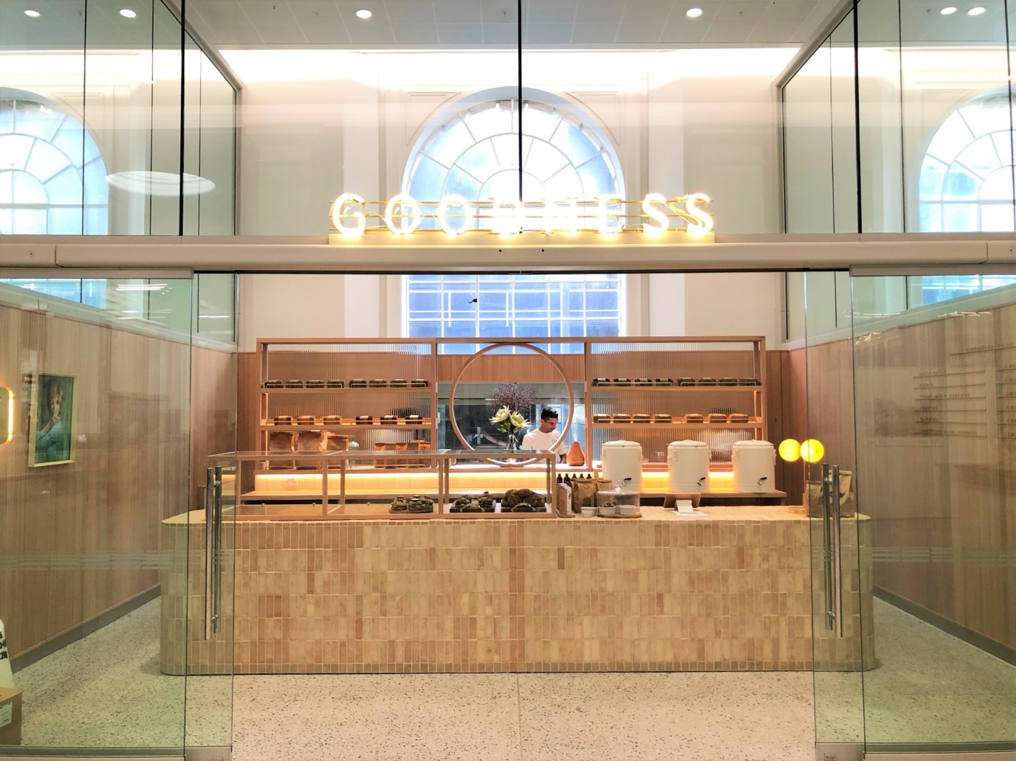

Table of Contents
1 Submission Checklist for participants 3
1.1 Information to be submitted by participants 3
2 EOI Attribute Response 4
2.1 Preconditions 4
2.2 Proposed use, product or service offering (25%) 4
2.3 Service delivery model (10%) 4
2.4 Rental offer and covenant strength (15%) 4
2.5 Track record (10%) 5
2.6 Business and marketing plan (15%) 5
2.7 Retail tenancy design and fit-out (25%) 5

Submission Checklist for participants

Information to be submitted by participants
This is an optional EOI response form to help guide the structure of your response. By using this template, respondents will ensure they have provided all requirements in line with the EOI evaluation criteria. You can complete the EOI response form in the fields within this template or send a custom response form.
If any information you provide is commercially sensitive to your business, you must let us know. Please mark the information ‘Commercially Sensitive’ or ‘Confidential Information’. It is not acceptable to render this whole document confidential unless this is truly the case.
The following information is to be submitted by each participant:
EOI Information
Documents | Included
Completed EOI Response Template (this document or your own version) | ☐
Precondition requirement as per Section 2.1 Precondition | ☐
Additional supporting documents | ☐

EOI Attribute Response
In this section you are asked to demonstrate your business’s ability against Evaluation Attributes set out on page 14 of the EOI document. If there is anything that you do not understand ask our Point of Contact to clarify before the Deadline for Questions.

Preconditions
You must be able to answer ‘yes’ to each of these precondition requirements. Make sure you are able to verify that this is the case, if asked.
Preconditions | Meets
You agree that: | Yes/No
The terms of Auckland Transport's Standard Agreement to Lease and Deed of Lease are acceptable.

The tenant is able to meet the timelines outlined on page 9 of the EOI document

The tenant acknowledges a willingness to work with Heritage New Zealand Pouhere Taonga to ensure the requirements for fitout design and plans meet all necessary heritage requirements.

Proposed use, product or service offering (25%)

Service delivery model (10%)

Rental offer and covenant strength (15%)

Track record (10%)

Business and marketing plan (15%)

Retail tenancy design and fit-out (25%)

